***3rd grade Work sheet 😺Name:***

***--------------------------‐-------------------------------------------------------------------------------------------------------***

***Q1. Read and answer the questions bellow:***

***In the attic, I'm Omar this is the attic in my home . There's an armchair behind the bookcase . There aren't any books on the bookcase. There are toys .***

***A)Find out :1)noun: 2) preposition:***

***B:1). Omar is on the..... a)bedroom.B) attic. C) garage***

***2)The armchair is ....the bookcase. A) opposite. B) behind. C) next to***

***3)..….. any books on the bookcase. A) There are. B) There aren't***

***4).....a sofa in the atticA) There isn't. B) There's***

……………………………………………………………………………………………………………………………………………………………………

2) listen and circle**(:**

**1) (There is/There are) a sofa. 2) ( There is/There are) a door**

**3)(There is/There are) armchairs. 4)(There is/There are) windows**

**5)(There is/There are) clock. 6)(There is/There are) mirrors.**

**................................................................................................**

**3. Circle the correct answer :**

1. **He ………………………………. A big house. ( have got / has got )**
2. **We ……………………………………… dirty pets . ( hasn’t got / haven’t got )**
3. **You ………………………………… a hard ball. ( has got / have got )**
4. **I ……………………………… a new drees. ( haven’t got / hasn’t got )**

**.........................................................................**

**4: Listen and write {cl._ Fl. _ Sh. _ Sl. }**

1. **………ug. 2)……….ean. . 3) ………..eep. 4)……..ag**

**5)fi……..**

**5:Match :**

**[ Wardrobe _Armchair _Television _ Book case [**

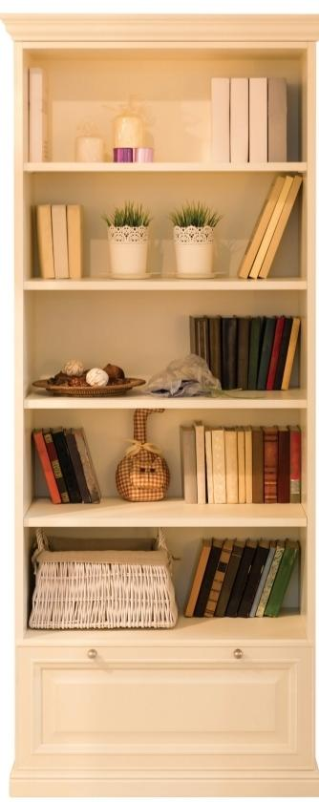

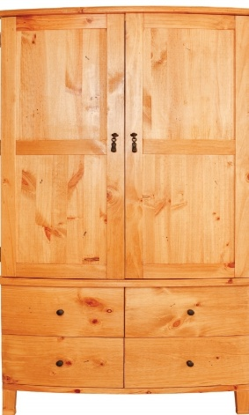

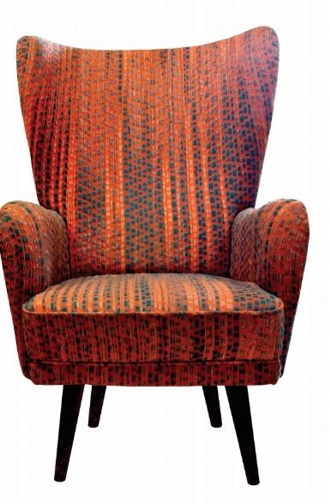

**..............................................................................,.**

**Best wishes**

**Miss Wegdan ❤️**