**Al frasah private school**

**Second semester – 2nd English exam**

**Name:____________________________**

**__________________________________________________________**

**Q1) look and match:**

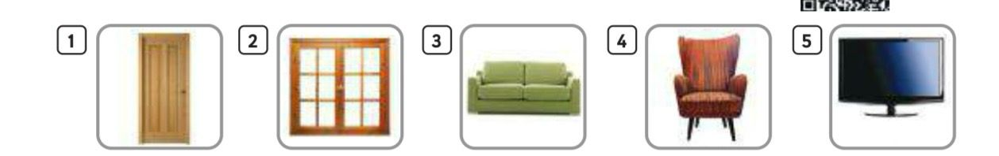

**window**

**door**

**armchair**

**sofa**

**Television**

**______________________________**

**Q2) Write the opposite adjective:**

**Clean wet old**

|  |  |
| --- | --- |
| **new** |  |
| **dry** |  |
| **dirty** |  |

**_____________________________________________________________________________________**

Q3) Write n the blank:

|  |  |
| --- | --- |
| Has got | Have got |

1_ Ali _________________ a new car.

2- They ___________________ a fancy kite.

3- she _______________ an old car.

4- Asma and Laila _____________ a new bags.

________________________________________________________

Q4) Listen and write:

**(Cl _sl_fl )**

____eep ___ag ___iff ___ean ___ug

__________________________________________________________

Q5) Translate into Arabic:

His car her car

_____________ ______________

GOOD LUCK